
Jurnal Komunikasi ISKI, Vol. XX (X), YYYY

J U R N A L

KOMUNIKASI
IKATAN SARJANA KOMUNIKASI INDONESIA

E-ISSN: 2503-0795
P-ISSN: 2548-8740
Title of Manuscript
Font size 18 bold times roman. Capitalize the first letter of nouns, pronouns, verbs, adjectives, and adverbs; do, not capitalize articles, coordinate conjunctions, or prepositions (unless the title begins with such a word)

http://dx.doi.org/10.25008/jkiski.xxxx

First Author^{1*} Second Author², Third Author³
(font size 13 bold Times Toman for author(s)

¹First affiliation, Address, City and Postcode, Country
²Second affiliation, Address, City and Postcode, Country
³Third affiliation, Address, City and Postcode, Country
*Corresponding author: (use official e-mail only)

Abstract
The abstract font size is 11 Times Roman. Make sure your abstract is in single spacing and is justified. Abstract text, maximum of 250 words providing trial information under the following sections. First, background. Provide context or background for the study and state the study’s primary objective or hypothesis in 1–2 sentences, is it theory review of communications. Mention and explained the theory that supports your research. Also, the author includes hypothesis (if any) which explained the tentative of the result. Second, methods. Describe the basic procedures used during the study, including the selection of study subjects and observational and analytical methods. Define the primary outcomes that were measured for each group of subjects about the implementation of communications. Third, results and discussion. Summarize the main findings, including specific effect sizes and their statistical significance, if possible. Also, please explain the previous research and relation between your theory and your result. Fourth, conclusion. In 1–2 sentences, state the principal conclusions, emphasizing new and important aspects of the study in the aspect of communications.

Keywords: Authors must supply five alphabetized keywords or phrases that identify the most important concepts in their paper. Examples of keywords could include theoretical concepts, methods used, geographical areas, or common communications themes. Keywords are separated with a semicolon (;).

Introduction
The introduction title and content should be in Times Roman, font size 11. Please make sure your article meets the word count requirement of 4000 – 8000 words. Your article may be returned to you if these requirements are not met. The first paragraph in each section should be left-aligned and each following paragraph should be indented. Text should be single-spaced with no space between paragraphs.
Introduction Section contains an explanation of why the issues need to be researched (research significance) and all supporting data or scientific evidence based on personal observations or the results of other researcher studies. The formulation of this research problem is always based on real conditions and objectively scientifically.
You must input your theoretical background on the Introduction section. After the theories are mentioned and discussed, you need to form a problem that shows why this manuscript is important, existing gaps, previous research and you as an Author must write the purpose of the manuscript.
Example of the existing gaps and previous research statement is in the end of Introduction section (after theories are mentioned and discussed): “........ (short summary of background)....... A previous researchers is explained on ....... This research is limited on ........ Indeed, this research intends to ................. The purpose of this research that related about communication are .........”.

Theoretical Framework
Theoretical background contains previous theories as the basis of research and the temporary hypothesis. The theory can be in the form of scientific articles, articles in journals, textbooks, or other sources of scientific writing. This theory will be used to provide state of the art of your manuscript from research problems that have been proposed. The theory that should be used primarily is the theory related to communications. Other theories that are still needed to solve the problem of research to support theories that are delivered after the theory of communication is discussed.

Material and Methodology
Methods are the means used by the author to answer the existing research problem. The method must clear with the location and time of the research, the population and sample of the research, the research variables and the research data. The method of your manuscript also mention in detail.

Result and Discussion
Result and discussion contain results obtained by the author during the research. The results of the research submitted in advance as a whole, which continues by doing the process of discussion. The discussion is presented systematically from general, then leads to the specific. Presentation of the research can be done with the help of tables, drawings/graphs, maps/plans, and schemes.
Result and discussion of your manuscript also interconnected with your theory that used, included novelty of your manuscript about communication. Minimum of your explanation on this chapter is range 40% to 50% of your manuscript.

Structure
Files must be in MS Word only and should be formatted for direct printing. Figures and tables should be embedded and not supplied separately. Please make sure that you use as much as possible normal fonts in your documents. To avoid unnecessary error you are strongly advised to use the ‘spellchecker’ function of MS Word. Follow this order when typing manuscripts: Title, Authors, Affiliations, Abstract, Keywords, Main text (including figures and tables), Acknowledgements, and References. Bulleted lists must not include for manuscript submission.

Tables
Tables should be centered, with titles located at the top of the table. Font style and size are Times Roman, 11 for table title and 10 for table contents. Please make sure your tables are legible and do not exceed page margins. All tables for submitting manuscript should be numbered with Arabic numerals and this tables can be edit and not as images. Every table should have a caption. Headings should be placed above tables. Only horizontal lines should be used within a table, to distinguish the column headings from the body of the table, and immediately above and below the table. Tables must be embedded into the text and not supplied separately. If the table get on other sources, write the name of source below the table, left justified. Below is an example which the authors may find useful.
Your table on the manuscript as much as possible in one page, not continued into next page. It is for the sake of ease for Reader that read your manuscript. Also, for mentioning your table, please mention your table with the number of your table. For example, “… the result of our research is mention on Table 4 …”. And please not mention your table with this example, “… the result of our research is mention on Table below …”.

Example of table formatting

Table 1. Involvement in Harassment
Behavior | Role | Level of Involvement | %
Harassment | Perpetrators | Never | 26.0
 |  | Low | 25.0
 |  | Medium | 24.0
 |  | High | 25.0
 | Victims | Never | 24.8
 |  | Low | 29.0
 |  | Medium | 22.5
 |  | High | 23.8
Source: Questionnaire #15

Format of references
References must be listed at the end of the paper. Do not begin them on a new page unless this is necessary. Authors should ensure that every reference in the text appears in the list of references and vice versa. Indicate references is fill by Last Name, Page, and Years, it is called Body Note or End Note. Here is example for you about Body Note or End Note.
“……… Women today have started to have the capacity to contribute from various aspects. For example, is in the office, college, business, and other things. However, not all women can always play an important role in the utilization of natural resources, particularly in the use of the watershed. (Stevenson, 2012: xx)….….”
Some examples of how your references should be listed are given at the end of this template in the ‘References’ section, which will allow you to assemble your reference list according to the correct format and font size.

Section headings
Section headings should be left justified, bold, with the first letter capitalized and numbered consecutively, starting with the Introduction. Sub-section headings should be in capital and lower-case italic letters, numbered 1.1, 1.2, etc, and left justified, with second and subsequent lines indented.

Footnotes
Footnotes on this manuscript is forbidden to be added. If your manuscript still has footnote on it, please correct your manuscript as soon as possible. And if you not correct your manuscript, your manuscript will be rejected.

Bullets and Numbering
For your manuscript, it is forbidden to use bullets and numbering. All sentence should be typed as descriptive paragraph format.

Figure
Figure titles are in Times Roman 10. The figure must be centered and must not exceed page margins. All figures should be numbered with Arabic numerals. Every figure should have a caption. All photographs, schemas, graphs and diagrams are to be referred to as figures. Line drawings should be good quality scans or true electronic output. Low-quality scans are not acceptable. Figures must be embedded into the text and not supplied separately. In MS word input the figures must be properly coded. Lettering and symbols should be clearly defined either in the caption or in a legend provided as part of the figure. Figures should be placed at the bottom of a page as possible to the first reference to them in the paper.
The figure number and caption should be typed below the illustration in 10 font and centered. If the figures get on other sources, write the name of source below the figures, left justified. The figures on your manuscript must send separately from your manuscript with high resolution. Below is an example which the authors may find useful.

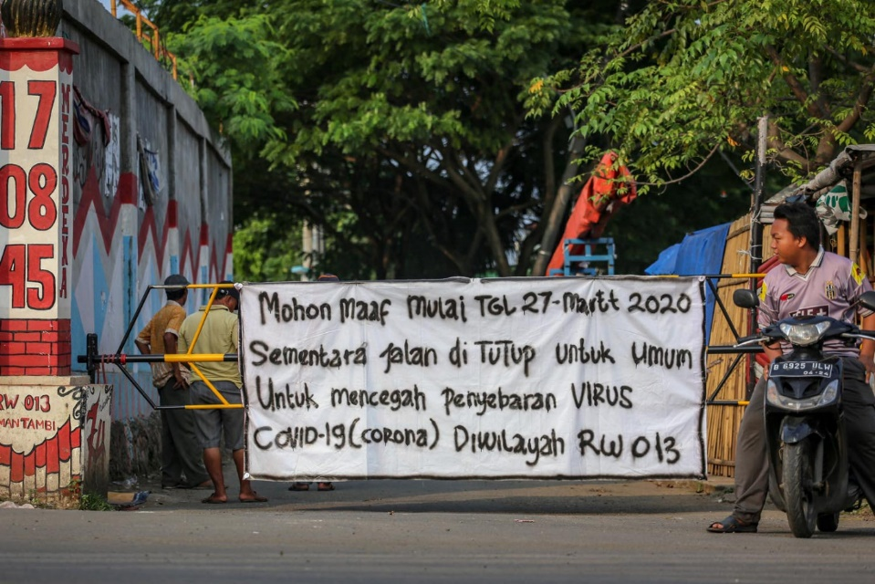
Figure 1. The road of kampong in West Jakarta was closed because of Covid-19
Source: Antara

Journal Publishing Agreement
All authors are required to complete the exclusive license transfer agreement before the manuscript can be published on Jurnal Komunikasi Ikatan Sarjana Komunikasi Indonesia. This document of agreement can be downloaded on website, which they can do online. This transfer agreement to protect the copyrighted material for the authors but does not relinquish the authors’ proprietary rights. The copyright transfer covers the exclusive rights to reproduce and distribute the article, including reprints, photographic reproductions, microfilm or any other reproductions of similar nature and translations. Authors are responsible for obtaining from the copyright holder, the permission to reproduce any figures for which copyright exists.

Conclusions
Conclusion of your manuscript is defined what is novelty of your manuscript to knowledge and benefit for society of communication and contribution theoretic from your manuscript. This conclusion is maximum 2 paragraph.

Acknowledgements (If Any)
Acknowledgements on this manuscript at the end of the manuscript before the references and do not, therefor, include them on the title page or otherwise. List on this tab those individuals or company that provided help during your research. The example of providing your research, e.g., providing language help, writing assistance, data collect, proof reading the article, etc.

References
References of your manuscript must be up to date (in the last of 5 to 10 years and minimum of 20 references that 80% of the references is from journal) and your reference can be accessed by anyone.
Format of the references for submitting manuscript on this journal with style of APA, which can be done in MS Word. Reference of your manuscript is organized alphabetically. Please input your references using Mendeley Application to facilitate you as an Author. Download Mendeley Application. Here are example references format with style of APA.

Journal Article: Andriani, F., Wiyati, E., Widarini, D., & Saifulloh, M. (2024). Acehnese's Digital Literacy Skills in Verification News from Social Media. Jurnal Komunikasi Ikatan Sarjana Komunikasi Indonesia, 8(2), 280-289. doi:https://doi.org/10.25008/jkiski.v8i2.752.
Book: Keyes, R. (2004). The Post-Truth Era: Dishonesty and Deception in Contemporary Life. New York: St. Martin Press..
Part of a Book: Boyd-Barrett, O., Rantanen. T. (2002). Theorizing the news agencies, in Dennis McQuail (ed). McQuail’s Reader in Mass Communication Theory, London: SAGE.
Conference paper (proceedings): Dahlan, M.D. and Tirtosudiro, T. (2010). A Quality System Based on ISO 9000 Combined with QFD, Proceedings: World Innovation & Strategy Conference 1998 Incorporating 4th International Symposium on Quality Function Deployment, 2-5 August, Sydney Australia. 1-8 (2010).
Internet: Arranged by the order of name (institution), title of article, and URL address, for example: The Bulgarian News Agency (BTA). Fragmenting Markets, Evolving Technologies among Challenges for News Agencies, EANA Conference Reveals. Retrieved on http://www.bta.bg/en/c/DF/id/1064325.

After Acceptance
Proofs and Copyright
Proofs will be sent by e-mail to the listed corresponding author. Any corrections must be returned within one week of receipt and should only cover typesetting errors. All corrections and the signed copyright form must be returned to us in one communication. Proofreading is solely the responsibility of the authors.

